

ELEX 3120/3321: Electric Circuits 2

LAB 1 – LabVIEW Instrumentation

|  |  |  |
| --- | --- | --- |
| Student Name: Enze Xu | Student Number: A01336393 | Set: B |

Table of Contents

1 Introduction 4

2 Pre-Lab 4

2.1 Temperature sensor conversion equation 4

2.2 Temperature sensor circuit with DAQ connections 4

2.3 Heater circuit with DAQ control connections 4

3 Experiments 5

3.1 LabView Implementation of Mathematical Equation 5

3.2 LabView Equation Implementation with myDAQ Input 6

3.3 LabView myDAQ Output Control of an LED Light 7

3.4 LabView Temperature Sensor Input, Conversion to Celsius and Display 7

3.5 LabView ON/OFF Temperature Control System 8

4 Conclusions 9

Table of Figures

Figure 1 - Temperature Sensor Circuit 3

Figure 2 - Heater Circuit 4

Figure 3 – Block Diagram of Implemented Mathematical Equation 4

Figure 4 - Front Panel of Implemented Mathematical Equation 5

Figure 5 - Block Diagram of Implemented Mathematic Function with myDAQ Input 5

Figure 6 - – Front Panel of Implemented Mathematic Function with myDAQ Input 6

Figure 7 - Block Diagram of Using myDAQ Output to Toggle an LED Light 6

Figure 8 - Front Panel of Using myDAQ Output to Toggle an LED Light 7

Figure 9 - Block Diagram of Temperature Sensor Input, Conversion to Celsius and Display 7

Figure 10 - Front Panel of Temperature Sensor Input in Celsius 7

Figure 11 - Block Diagram of ON\OFF Temperature Control System 8

Figure 12 - Front Panel of ON\OFF Temperature Control System 8

# Introduction

This Lab is to introduce the basic features of LabView & myDAQ, including implementing functions, setting myDAQ input & output. The Lab also aims to build a temperature sensing control system using LM335.

# Pre-Lab

## Temperature sensor conversion equation

$$T_{C}= \frac{V_{out}}{10 mV/K}-273.15K$$

## Temperature sensor circuit with DAQ connections

## 

Figure 1 - Temperature Sensor Circuit

## Heater circuit with DAQ control connections

Figure 2 - Heater Circuit

# Experiments

## LabView Implementation of Mathematical Equation

Figure 3 – Block Diagram of Implemented Mathematical Equation

Figure 4 - Front Panel of Implemented Mathematical Equation

## LabView Equation Implementation with myDAQ Input

Figure 5 - Block Diagram of Implemented Mathematic Function with myDAQ Input

Figure 6 - – Front Panel of Implemented Mathematic Function with myDAQ Input

## LabView myDAQ Output Control of an LED Light

Figure 7 - Block Diagram of Using myDAQ Output to Toggle an LED Light

Figure 8 - Front Panel of Using myDAQ Output to Toggle an LED Light

## LabView Temperature Sensor Input, Conversion to Celsius and Display

Figure 9 - Block Diagram of Temperature Sensor Input, Conversion to Celsius and Display

Figure 10 - Front Panel of Temperature Sensor Input in Celsius

## LabView ON/OFF Temperature Control System

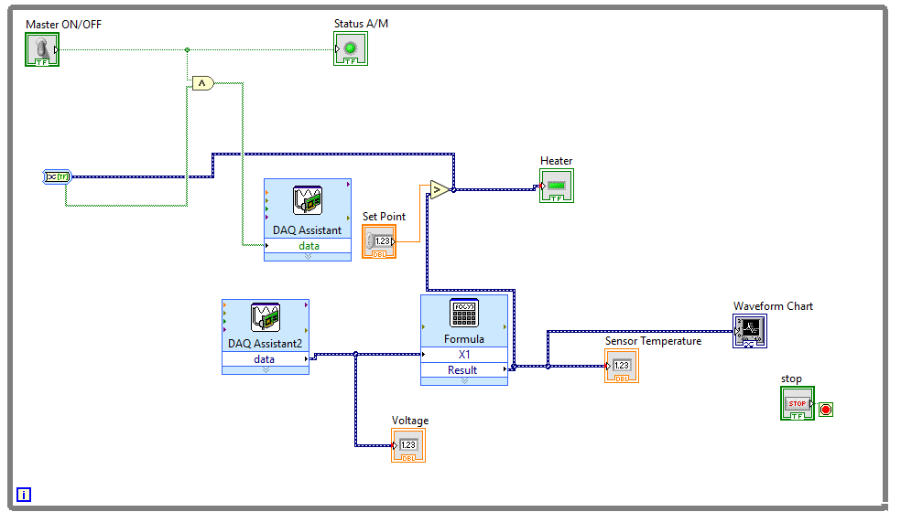

Figure 11 - Block Diagram of ON\OFF Temperature Control System

Figure 12 - Front Panel of ON\OFF Temperature Control System

# Conclusions

In conclusion, this lab provided a hands-on experience with LabVIEW and the myDAQ system for data acquisition and control. Through various tasks, including equation implementation, signal input/output control, and temperature sensor integration, the lab demonstrated how to use LabVIEW to interact with hardware in a real-world application. The successful implementation of a temperature control system, complete with an electric heater and ON/OFF control, highlighted the practical use of instrumentation in electronic circuits.